|  |  |
| --- | --- |
| cetlogo ***CHEMICAL ENGINEERING TRANSACTIONS***  ***VOL. xxx, 2025*** | A publication of  aidiclogo_grande |
| The Italian Association  of Chemical Engineering  Online at www.cetjournal.it |
| Guest Editors: Fabrizio Bezzo, Flavio Manenti, Gabriele Pannocchia, Almerinda di Benedetto  Copyright © 2025, AIDIC Servizi S.r.l. **ISBN** 979-12-81206-17-5; **ISSN** 2283-9216 | |

Hydrothermal Carbonization of Agro-Industrial By-Products for the Production of Valuable Chemicals

Fabrizio Di Caprio\*, Flavia Marzulli, Pietro Altimari, Marianna Villano, Francesca Pagnanelli

aDipartimento di Chimica, Università Sapienza di Roma, Piazzale Aldo Moro 5, 00185, Rome, Italy

\*fabrizio.dicaprio@uniroma1.it

The development of a sustainable bioeconomy requires the application of effective technological solutions to recycle organic molecules into valuable products. Hydrothermal treatments are thermochemical processes that can be employed to depolymerize biomass into small organic molecules suitable for new applications. Most of the research on hydrothermal processes has focused on the stabilization of the organic compounds, producing a carbonaceous hydrochar material, while less attention has been given to the extraction of valuable organic molecules. In this study, we investigated the effects of temperature (160 and 190 °C) and reaction time (15 and 60 min) on the hydrothermal treatment of two different biomasses: orange peels and barley straw. Both the solid hydrochar and the aqueous extracts were chemically characterized. Specifically, the aqueous extracts were analyzed for their content of released organic molecules and were tested by respirometry to assess their potential as substrates for microbial fermentations. Results showed that lower temperatures and shorter reaction times led to the release of higher concentrations of soluble organic molecules, reaching a COD (Chemical Oxygen Demand) value up to 161 g L⁻¹, phenols up to 5.5 g L⁻¹, and carbohydrates up to 47 g L⁻¹. Orange peels released the highest concentrations of organic molecules in the process water, but this water was poorly biodegradable by mixed microbial cultures (21% biodegradable COD). The process water from the hydrothermal carbonization of barley straw at 190 °C for 15 minutes was the most biodegradable stream (34% biodegradable COD) between those investigated and was the most suitable for microbial fermentation, due to its higher acetic acid content. This stream did not cause short-term inhibition of microbial cultures. These preliminary results are promising, but further work is needed to optimize the application of these streams for the production of specific value-added products

* 1. Introduction

Hydrothermal carbonization (HTC) is a thermochemical process conducted in closed reactors at temperatures ranging from 150 to 350 °C, under autogenous pressure of 2–20 MPa. This process exploits the solvent properties of subcritical water, reduced dielectric constant and increased acid constant, to promote a series of reactions including hydrolysis, dehydration, decarboxylation, aromatization, and condensation (Khan et al., 2021). HTC holds significant promise for the treatment of wet wastes and by-products, as it eliminates the need for preliminary drying and allows the recovery of small organic molecules and minerals in the water phase. The process yields two main phases: a solid and a liquid phase, both of which can be exploitable to produce chemicals. The solid phase, a carbon-rich material, has potential applications as an adsorbent, soil amendment, or in battery manufacturing. The liquid phase contains low molecular weight organic molecules and inorganic elements derived from leaching and depolymerization of biomass, making it suitable for use in biotechnological and chemical applications, such as fertilizers, bioplastics, and industrial microbiology. The typically HTC operating temperatures result in a sterile aqueous phase, regardless of feedstock contamination, which is particularly suitable for biotechnological applications. So far, HTC has been primarily applied for the production of hydrochar used as soil amendment or adsorbent (Islam et al., 2021). To be applied to other industrial applications, reactor operating conditions should be optimized to obtain high yield of the end-product targeted, at minimum costs. At low reaction times, hydrolysis prevails during HTC, leading to the release of small organic molecules. At larger reaction times, polymerization prevails leading to an increase in yield of primary and secondary char (Di Caprio et al., 2022). In the aqueous phase, acetate is usually among the predominant organic acids produced, with values ranging between 0.7 and 33 g L−1 (depending on the operative conditions), contributing from 5 to 50% of total organic carbon (Stemann et al., 2013). A fraction of the treated biomass is always missed as CO2 gas (Wang et al., 2018). Other chemicals commonly found in HTC water are formic acid, lactic acid, propionic acid, phenols, hydroxymethylfurfural (HMF) and furfural, which can have antimicrobial effects on microorganisms (Proietti Tocca et al., 2024). Using mild HTC conditions (140-200 °C, 10 – 60 min), the carbonization phase can be minimized, obtaining larger yields of end-products deriving from the hydrolysis phase.

This study explores the valorization potential of two agro-industrial by-products: barley straw and orange peels. These are two biomasses currently produced as by-products from different agro-industrial sectors. Orange peels represent a significant source of organic waste, often discarded in large quantities despite their rich content of valuable compounds. They represent about 50% of the waste of orange from the industrial production of orange juice. Barley is widely used for the production of baked goods and beer. Barley straw is a relevant by-product from barley production, currently employed mainly as feed. HTC could represent an alternative and innovative way to valorize barley straw and orange peels in valuable end-products.

The objective of this study was to evaluate hydrochar production alongside with the synthesis of carboxylic acids, with the latter possible serving as feedstock for polyhydroxyalkanoates (PHA) production. PHA are a family of microbial polyesters, both biodegradable and biobased, that could replace conventional plastics in many applications (Acharjee et al., 2022). To this aim HTC was assessed at varying reaction times (15–60 min) and temperatures (160–190 °C).

* 1. Materials and methods
     1. Hydrothermal carbonization (HTC) treatment

Orange peels were frozen, then freeze-dried, cut into small pieces with scissors, and freeze-dried again until moisture content was below 10%. Then they were ground with a blender to obtain a fine powder (< 1 mm), which was stored into plastic bags. Dried barley straw was micronized and sieved to obtain particles < 1mm. HTC was performed by mixing 5.0 g of biomass with 20 mL water in a 100 mL polytetrafluoroethylene (PTFE) vessel. The biomass suspensions were treated at 200 °C for 30 min using the Milestone Laboratory Microwave System Labstation. Different experiments were carried out to test the effect of two different temperatures and two different reaction times, in a 22 factorial design (Figure 1). Each different experimental condition was replicated twice. For each test, the heating time took 5 min, then the vessel was maintained at the prescribed temperature for the prescribed time, and then the vessels were cooled down in 30 min. The solid hydrochar produced was separated from the liquid phase by vacuum filtration through 8-12 μm filter paper and then dried at 105 °C. The obtained liquid phases were stored at −20 °C before analysis.

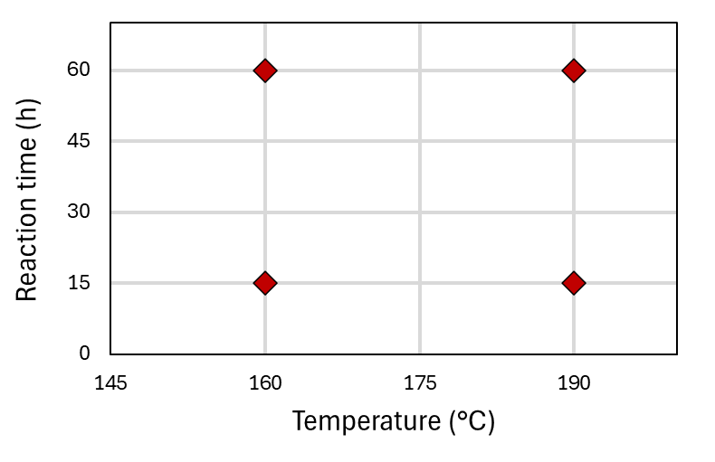

*Figure 1: HTC experimental design.*

The yield of the hydrochar sample (YH) was determined by Eq. 1:

$Y_{H}=\frac{X_{H}}{X_{B}}$ (1)

With XH the mass of the recovered hydrochar and XB the initial biomass.

Based on the carbon content inside hydrochar (%C,H) and raw biomass (%C,B), the carbon yield (YC,H) was determined by Eq. 2:

(2)

* + 1. Chemical characterizations

Hydrochar elemental composition was determined by CHNS analysis carried out by an elemental analyzer (EA 1110 CHNS/O). Total phenols in the water extract were determined as tyrosol equivalents by the Folin-Ciocalteau method (Di Caprio et al., 2021). Soluble COD was determined by using a commercial kit from Macherey Nagel (100 - 1,500 mg L-1), incubating samples for 2 h at 148 °C, reading the absorbance at 610 nm after 45 min of cooling. Total carbohydrates in the water extract were determined by using the phenol-sulfuric acid method (Dubois method): 1 mL of 5% phenol solution and 5 mL of 96% sulfuric acid were added to 2 mL sample, mixed, cooled 10 min at environmental temperature and 10 min in a water bath at 27 °C, then absorbance was read at 490 nm and quantification made using a calibration line obtained with glucose. The concentration of carboxylic acids (e.g., acetic acid, propionic acid, butyric acid) in the extracts was determined using a Dani Master gas chromatograph equipped with a 4% Carbowax 20M, 80/120 Carbopack B-DA and a flame ionization detector (FID). The column was maintained at 175 °C and eluted with 25 mL min-1 nitrogen. Analysis of PHA (i.e., poly-3-hydroxybutyrate-3-hydroxyvalerate-3-hydroxyhexanoate) was performed during the respirometry test by collecting 5 mL of reactor mixed liquor at regular intervals and immediately adding 1 mL of sodium hypochlorite (NaClO) solution to degrade the cell wall of microorganisms and avoid the microbial consumption of the stored polymer. For the polymer analysis, an acid-catalyzed methanolysis was performed using methanol acidified with H2SO4 at 3% (v/v) (Braunegg et al., 1978). An Agilent 8860 gas chromatograph equipped with FID was used for the PHA analysis.

* + 1. Respirometry tests

To conduct these tests, 500 mL of biomass was collected from the Famine reactor of a continuous process dedicated to PHA production with mixed microbial cultures (MMC) (Tayou Nguemna et al., 2023). The collected biomass was left overnight under continuous stirring and aeration to remove any residual organic matter. The oxygen consumption rate due to the endogenous metabolism (*r*Oend) as well as the oxygen transfer coefficient (KLa) were predetermined before starting the tests. During the tests, spikes of acetic acid and HTC liquid extracts were subsequently supplied at a concentration of approximately 0.55 gCOD L-1. A further addition of acetic acid was provided after approximately one day from the beginning of the tests, to verify the ability of the microbial population to retain its biological activity also in presence of non-degraded HTC extracts. During the tests, samples were collected at different intervals of time to perform chemical analysis for the determination of acids, COD, and PHA. The dissolved oxygen (DO) concentration was continuously monitored throughout the test by means of a DO probe ProfiLine Oxi 3310 (WTW).

* + 1. Data analysis

Experiments were conducted in duplicate. Significant difference among samples were tested by analysis of variance (ANOVA) in Microsoft Office Excel, considering α = 0.05. Errors are indicated as ± standard deviation.

* 1. Results and discussion
     1. Hydrothermal carbonization of orange peels and barley straw

Temperature and reaction time are two operating parameters with high impact on the HTC process. The ranges between 160 - 190 °C and between 15 - 60 min were set in this study to improve the release of small organic molecules in the water phase, available for microbial fermentation. Indeed, short reaction times and low temperature should improve the release of hydrolytic products over condensation reactions (Di Caprio et al., 2022). Total organic molecules, measured as COD, were released in the water phase at concentrations between 22 - 161 g L-1, with the highest values attained for orange peels at shorter reaction times and lower temperatures (Figure 2). For both biomasses there was even a significant interaction between temperature and reaction time on the release of COD. Orange peels also showed higher releases of carbohydrates and phenols. Also for carbohydrates and phenols, orange peels allow the achievement of higher concentrations. Released carbohydrates ranged between 6 and 47 g L-1, with higher concentrations achieved with orange peels. Higher carbohydrate concentrations were attained at higher reaction times at 160 °C and at lower reaction times at 190 °C (Figure 2). These results indicate that it should be found a compromise between reaction time and temperature to allow sufficient release but avoiding excessive degradation of carbohydrates. Phenols ranged between 1.9 and 5.5 g L-1, with higher concentrations at lower temperatures, without significant effect of reaction time.

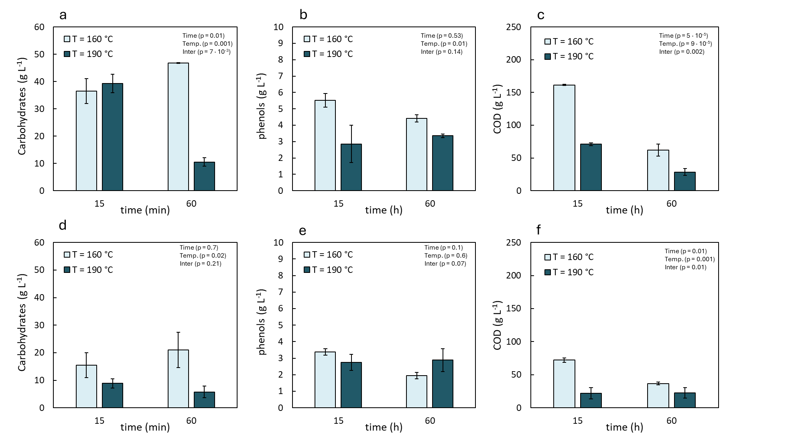

*Figure 2: Release of carbohydrates, phenols and COD in the process water after HTC treatment of orange peels (a, b, c) and barley straw (d, e, f). p-values from ANOVA are reported to assess the effect of temperature, time and interaction.*

The higher release of organic compounds from orange peels is likely due to a higher content of soluble carbohydrates in orange peels (as simple sugars, pectin, hemicellulose) than in barley straw, mostly made of cellulose.

Solid hydrochar obtained were also analyzed and results reported in Table 1. Orange peels gave lower hydrochar yield and lower C yield as hydrochar than barley straw, in agreement with the higher release of organic compounds in the water phase. In all hydrochar samples there was an increase in C and N content, and a decrease in H and O content, due to de-hydration reactions occurring during carbonization. For both orange peels and barley straw, higher C content, lower H and O contents, and lower hydrochar yield were achieved with the samples treated at higher reaction time and temperature, in agreement with previous results on other biomasses (Hoekman et al., 2011).

Table 1: Elemental composition, YH and YC,H for the different hydrochar samples produced from orange peels (HCOP) and barley straw (HCBS) at different temperatures (160 or 190 °C) and reaction times (15 or 60 min).

|  |  |  |  |  |  |  |
| --- | --- | --- | --- | --- | --- | --- |
|  | C (%) | H (%) | N (%) | O (%) | YH (%) | YC,H (%) |
| Orange peels | 41 | 6.61 | 0.82 | 52 | - | - |
| HCOP 160, 15 | 46 ± 1 | 6.11 ± 0.02 | 1.3 ± 0.1 | 46 ± 2 | 59.1 ± 0.6 | 67 ± 1 |
| HCOP 160, 60 | 48 ± 2 | 5.54 ± 0.04 | 1.34 ± 0.04 | 45 ± 2 | 50.0 ± 0.1 | 59 ± 2 |
| HCOP 190, 15 | 48.4 ± 0.2 | 5.6 ± 0.3 | 1.31 ± 0.01 | 44.7 ± 0.1 | 46 ± 3 | 55 ± 4 |
| HCOP 190, 60 | 56.7 ± 0.6 | 5.6 ± 0.2 | 1.62 ± 0.01 | 36.1 ± 0.7 | 47 ± 5 | 66 ± 7 |
| Barley straw | 43 | 6.15 | 0.53 | 50 | - | - |
| HCBS 160, 15 | 50.5 ± 0.9 | 5.6 ± 0.3 | 0.61 ± 0.04 | 43.3 ± 0.7 | 64 ± 2 | 79 ± 4 |
| HCBS 160, 60 | 53 ± 3 | 5.83 ± 0.07 | 0.60 ± 0.05 | 41 ± 3 | 60 ± 6 | 78 ± 3 |
| HCBS 190, 15 | 52 ± 1 | 5.8 ± 0.4 | 0.59 ± 0.01 | 42 ± 2 | 64 ± 3 | 81 ± 2 |
| HCBS 190, 60 | 55 ± 3 | 5.8 ± 0.1 | 0.65 ± 0.08 | 39 ± 3 | 55 ± 4 | 74 ± 2 |

The water extract derived from HTC of the orange peels was characterized by a high total COD content (up to 161 ± 1 g L-1 for 15 min reaction time), but negligible concentrations of soluble carboxylic acids necessary for PHA production by mixed microbial cultures (MMC) were detected. Instead, the aqueous extracts from HTC performed on barley straw at both 160 °C and 190 °C showed a higher organic acid content, despite the lower total COD content than the orange peel water extract. The resulting CODACIDS/CODtot ratio of HTC water from barley straw was 8% and 17% for HTC performed at 160 °C and 190 °C (for 15 minutes), respectively. However, HTC water obtained from both biomasses underwent respirometry tests. The aqueous extract from the HTC treatment of orange peels at 160 °C for 15 min showed a low biodegradability (with only 21% COD consumption). This was likely due to the excessively high concentration of phenols and other antimicrobial compounds.

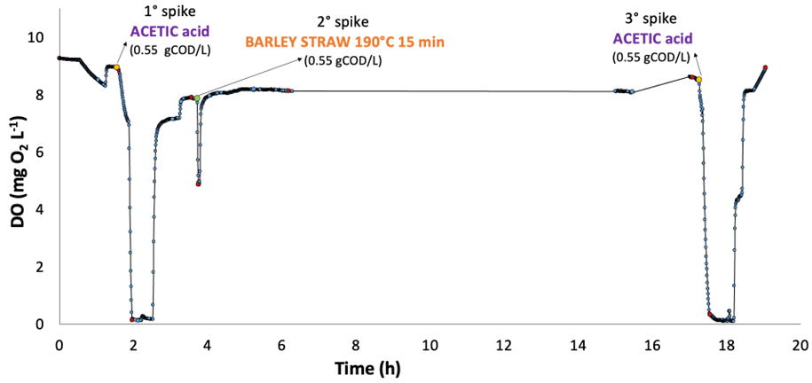

Figure 3: Trend of the Dissolved Oxygen (DO) concentration during a respirometry test performed with water extract from HTC at 190°C and 15 min of barley straw. The red dots refer to the moments of sampling of the liquid phase and the green/yellow dots to the moments when the acetic acid and HTC water spikes were provided, respectively. The initial part of the test was used to calculate the oxygen transfer coefficient.

Samples from barley straw treated at 190 °C for 15 min showed a higher biodegradability, with an overall soluble COD consumption of approximately 34%, and a complete consumption of carboxylic acids (mainly consisting of acetic acid) during respirometry tests. When the latter was performed with water extract from barley straw treated at 160 °C for 15 min, the COD consumption accounted for 29% and the acid consumption (up to 71%) was not complete. These results clearly indicate that the operating conditions applied to the HTC process strongly affect the biodegradability of water extracts. Also, it is worth mentioning that in all performed tests PHA were not produced. Finally, no short-term inhibitory effects of the process water on the microbial activity were detected, as indicated by the profile of dissolved oxygen (DO) concentration during the respirometry tests performed with barley straw treated at 190 °C (Figure 3). Indeed, the sudden decrease of the DO concentration in response to the acetic acid supply, either before (at around 2 h from the beginning of the test) or after the addition of barley straw HTC water extract (i.e., after ca. 17 h from the beginning of the test), clearly indicates the occurrence of the microbial activity due to the consumption of the external carbon source which, once completely depleted, caused a rapid increase of the DO concentration. This suggests the presence of recalcitrant compounds but not inhibitory for the microbial activity in the used HTC water extract. Also, the low fraction of readily biodegradable COD (about 17 %) was quickly consumed, as shown by the rapid decrease of DO concentration from 7.85 mg L-1 to 4.84 mg L-1, following its supply (at approximately 3.7 h) which quickly resumed to previous values. However, the DO concentration continued to gradually increase, up to ca. 8.60 mg L-1 at around 18 h from the beginning of the test, likely due to the consumption of part of the slowly biodegradable fraction of the supplied COD. Overall, these data point to the possibility to exploit the HTC water extract of barley straw to get valuable products through microbial fermentation upon tuning its composition by changing the HTC operating conditions.

* 1. Conclusions

The chemical composition of the process water obtained from HTC is strongly affected by the kind of treated biomass, and by operating conditions as temperature and reaction time. Lower temperature and shorter reaction times allow the release of higher concentrations of soluble organic molecules. Orange peels released higher concentrations of organic molecules in the process water, but this water resulted scarcely biodegradable by mixed microbial cultures. Process water from the HTC of barley straw carried out at 190 °C and 15 min was the most biodegradable stream among those investigated, and suitable for microbial fermentation due to the high content of acetic acid and no short-term inhibitory effects on microbial activity. Further work is required to optimize the application of this stream for the production of specific added-value products.

Acknowledgement

This study was carried out within the Agritech National Research Center and received funding from the European Union Next-GenerationEU (PIANO NAZIONALE DI RIPRESA E RESILIENZA (PNRR) – MISSIONE 4 COMPONENTE 2, INVESTIMENTO 1.4 – D.D. 1032 17/06/2022, CN00000022). This manuscript reflects only the authors’ views and opinions, neither the European Union nor the European Commission can be considered responsible for them.

References

Acharjee, S. A., Bharali, P., Gogoi, B., Sorhie, V., Walling, B., Alemtoshi, 2022, PHA-Based Bioplastic: a Potential Alternative to Address Microplastic Pollution, Water, Air, & Soil Pollution, 234, 1–31.

Braunegg, G., Sonnleitner, B., Lafferty, R. M., 1978, A rapid gas chromatographic method for the determination of poly-β-hydroxybutyric acid in microbial biomass, European Journal of Applied Microbiology and Biotechnology, 6, 29–37.

Di Caprio, F., Pellini, A., Zanoni, R., Astolfi, M. L., Altimari, P., Pagnanelli, F., 2022, Two-phase synthesis of Fe-loaded hydrochar for As removal: The distinct effects of initial pH, reaction time and Fe/hydrochar ratio, Journal of Environmental Management, 302, 114058.

Di Caprio, F., Pipitone, L. M., Altimari, P., Pagnanelli, F., 2021, Extracellular and intracellular phenol production by microalgae during photoautotrophic batch cultivation, New Biotechnology, 62, 1–9.

Hoekman, S. K., Broch, A., Robbins, C., 2011, Hydrothermal Carbonization (HTC) of Lignocellulosic Biomass, Energy Fuels, 25, 1802–1810.

Islam, M. A., Limon, M. S. H., Romić, M., Islam, M. A., 2021, Hydrochar-based soil amendments for agriculture: a review of recent progress, Arabian Journal of Geosciences, 14, 1–16.

Khan, N., Mohan, S., Dinesha, P., 2021, Regimes of hydrochar yield from hydrothermal degradation of various lignocellulosic biomass: A review, Journal of Cleaner Production, 288, 125629.

Proietti Tocca, G., Agostino, V., Menin, B., Tommasi, T., Fino, D., Di Caprio, F., 2024, Mixotrophic and heterotrophic growth of microalgae using acetate from different production processes, Reviews in Environmental Science and Bio/Technology, 23, 93–132.

Stemann, J., Putschew, A., Ziegler, F., 2013, Hydrothermal carbonization: Process water characterization and effects of water recirculation. Bioresource Technology, 143, 139–146.

Tayou Nguemna, L., Marzulli, F., Scopetti, F., Lorini, L., Lauri, R., Pietrangeli, B., Crognale, S., Rossetti, S., Majone, M., Villano, M., 2023, Recirculation factor as a key parameter in continuous-flow biomass selection for polyhydroxyalkanoates production, Chemical Engineering Journal, 455, 140208.

Wang, T., Zhai, Y., Zhu, Y., Li, C., Zeng, G., 2018, A review of the hydrothermal carbonization of biomass waste for hydrochar formation: Process conditions, fundamentals, and physicochemical properties, Renewable and Sustainable Energy Reviews, 90, 223–247.